**CSR PLAYBOOK**

**Table of Contents**

1. Introduction 2

2. Prerequisites 2

3. Application Process 2

3.1. Elevator Pitch 2

3.2. Presentation for the CSR committee 2

3.3. Detailed Application 2

3.4. Templates and Frameworks 2

3.4.1. Budget/Financial details 2

3.4.2. User Research 3

4. Do’s and Don’ts 4

5. Best Practices 5

6. Sample Applications 6

7. References & Useful Links 6

# **Introduction**

**Corporate Social Responsibility** (**CSR**) is the **funding** and **grants** process under which Non-Profit Organisations (NGOs) can get financial and other support from the corporate sector. Under the Companies Act, 2013 it is a mandatory provision to provide a contribution of 2 percent of the average net profits of companies.

Under Section 135, every company having net worth of at least ₹500 crore, turnover of ₹1000 crore or more, or a minimum net profit of ₹5 crore during the immediately preceding financial year has to make CSR expenditure.

# **Prerequisites**

* You will need to partner with a NGOs to bring you access to funding. Companies fund NGOs for their CSR activities.
* Your NGO partner will act as the manager of the project or program.
* Know prospective company’s CSR policy, focus areas & programs. Sources are
  + Your current supporters who may know leaders at prospective company
  + Company website, more specifically their CSR page
  + Company’s Annual CSR brochure / report
  + CSR conferences, press articles
  + Websites of CSR organizations supported by them
  + Events supporting CSR (TCS 10K)
* Understand how your program matches their CSR policy & focus areas before applying for the CSR fund

# **Application Process**

# **Elevator Pitch**

If you plan to have an elevator pitch, please add here.

# **Presentation for the CSR committee**

Please refer to **CSR Proposal Summary** from the CSR package from AssisTech Foundation.

# **Detailed Application**

Please refer to **CSR Detailed Proposal** from the CSR package from AssisTech Foundation.

# **Templates and Frameworks**

# **Budget/Financial details**

Please refer to the **CSR Proposal Budget** from the CSR package from AssisTech Foundation.

# **User Research**

Below is a framework for helping to access, understand and present details on the target users in a clear and concise manner.

1. Create a plan to access the needs and resources

* Needs are the gap between what a situation is and what it should be
* Resources are those things that can be used to improve the quality of life for the target group.
* A plan when executed should help you to understand the environment and help you make decisions about priorities

1. Use quotes, live examples, references, research data and press articles to validate your numbers. It has to be very specific to funder issues and priorities. Giving references to other [NGOs](https://www2.fundsforngos.org/tag/ngos/), Governmental work in the area working against the same problem would be useful.
2. Collect and share demographics. The below data points can indicate the demographic profile of the population

* Age
* Gender
* Race and ethnicity
* Marital status
* Education
* Number of people in household,
* First language
* Poverty information, including information on the state of the economy
* Gender issues
* Gather Economics such as who are the major employers in the community?  What, business or industry (if any) is the community's base?

1. Use qualitative methods to assess more details on the issue

* Start with what you know
* Decide what information is missing.
* Divide the information into
* Facts
* Inference
* Speculation
* Opinion

1. Collect information about the problem and target population

Justify the choice of the priority problem or goal to be addressed. Include:

* How often does the problem occur?
* How many people are affected and how much you can address?
  + World
  + India
  + Local

Or

* + Total Addressable Market (TAM)
  + Serviceable Available Market (SAM)
  + Serviceable Obtainable Market (SOM)

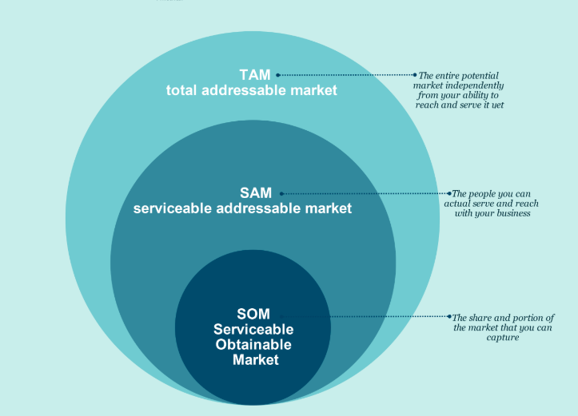

* For what amount of time are they affected?
* How severe (significant) is the effect?
* How important is the problem or goal perceived to be by others?
* How effective are efforts to address it likely to be?
* Are there any likely negative impacts of addressing the problem or goal?

# **Do’s and Don’ts**

* **DO** Partner with an NGO which has the following certificates
  + 80G registration (Provides 50% Income Tax exemption to the donor)
  + 12A registration (Tax-free income for NGO)
  + NGO Registration certificate.
* **DO** remember, foreign companies may donate funds only if the NGO has an FCRA (Foreign Contribution Regulation Act) registration.
* **DO** Identify & reach out to the key influencers of the company’s CSR program (CSR committee members) once you’ve identified the company for CSR fund.
* **DO** remember that you will get thirty minutes to an hour for the presentation pitch.
  + Keep it short & simple
  + Not more than 10 slides for a thirty-minute presentation
  + Spend 3 -4 minutes on each slide, emphasize ‘the key take-way’ for slide
  + Keep 15 to 25 minutes for discussion on a CSR program that may be of interest to them
  + Identify key areas of interest that will be fulfilled by the CSR program
  + Employee engagement/volunteering, social impact & how to measure it
  + Understand reporting requirements, evaluation process & sequence of steps
  + Proposal to clearly address all of the above – prepare slides of proposal
* **DON’T** ignore Gender in your proposal
  + Try to add a gender component throughout the proposal, not merely a section. This maybe a bit difficult to conceive, yet it gives a better chance of success for the project at the founder's desk
* **DON’T** forget to communicate. In all aspects of grant management, problems can be avoided with clear and regular communications with grants officers. Put everything in writing.
* **DON’T** make payments or enter into commitments before the agreed contract start date. All invoices must be dated between the official start and end dates.
* **DON’T** underspend!If you do not use up all of their allocation, the donors may then lose this money from their next year’s allocation.

# **Best Practices**

* Share progress of CSR program, budget spend & measurement of social impact with the funders on regular basis
* Funders often want to see a plan for how the project or group will be maintained after the grant period.
  + Create a business plan to anticipate what resources will be necessary to sustain the organization or effort.
  + Identify specific tactics to be used to sustain the effort (e.g., sharing positions and resources, becoming a line item in an existing budget).
* Create and shared measurable goals including clearly laying out risks
* Create page on your website that can be accessed by employees
* Make influencers ‘look good /feel good’ – that they have supported a worthy partner & cause
  + Cheque presentation event, photo-op for internal publicity
  + Create participation events and invite influencers during roll out of CSR program
  + Include visibility in your company’s publicity programs
  + Talk about CSR program & social impact in public forums, share press coverage
* Demonstrate commitment to cause, execution excellence & financial transparency
* Meet corporate leads in parent company - highlight program & its social impact.
* Upgrade program to deliver greater social impact & connect with supporting company
* Put Description of the Community who will benefit from the project or program
  + Describe the geographic area that defines the community (e.g., city, town or village, urban neighbourhood or rural area), including the location and physical boundaries, total population, and other relevant characteristics (e.g., commercial/residential area, quality of physical environment, etc.)
  + Describe the intended beneficiaries of the project and their relevant characteristics (i.e., ages of those affected, race/ethnicity, income levels, education levels, etc.)
  + State community assets, challenges, and needs
  + State other recent and current efforts in the community to address the problem/ goal
* It is best to use a language which is sensitive to gender. Language is often patriarchal and therefore carries and reflects gender biases and inequalities.
* If you cannot meet reporting deadlines or fulfil other conditions, warn the donor as soon as possible; don’t ignore it. You may be able to negotiate on unrealistic terms and conditions.

# **Sample Applications**

* <https://csrbox.org/India-csr-project-proposals> (contain short/medium details on 90 CSR projects)
* <https://www.canarahsbclife.com/pdf/Krishi_Proposal.pdf>
* <https://www.rotary.nl/zwijndrechtwaalendevel/activiteiten/archief/Project%20Proposal%20Mikka.pdf>
* <https://www.globalgiving.org/pfil/6045/projdoc.pdf>
* <http://www.pitt.edu/~ginie/lebanon/pdf/crcnyhq1.pdf>
* <https://assets.speakcdn.com/assets/2332/botswanawildproposal.pdf>
* <https://iimpact.org.au/wp-content/uploads/2016/05/Project-Proposal-for-IIMPACT-Australia-2016_o.pdf>
* <https://www.wcu.edu/WebFiles/ocjs_sample_grant.pdf>

# **References & Useful Links**

* <https://www.csr.gov.in/>
* <https://www.cisco.com/c/en/us/about/csr/community/nonprofits/global-impact-cash-grants.html#~stickynav=3>
* <http://cec.vcn.bc.ca/cmp/modules/res-prp.htm>
* <https://ctb.ku.edu/en/table-of-contents/analyze/analyze-community-problems-and-solutions/define-analyze-problem/main>
* <https://www.fundsforngos.org>
* <https://www.vanderbilt.edu/corporate-foundation-relations/grantwriters-toolkit/contents-of-proposal.php>
* [https://www.prezly.com/academy/relationships/corporate-social-responsibility/10-examples-of-exemplary-csr-initiatives#](https://www.prezly.com/academy/relationships/corporate-social-responsibility/10-examples-of-exemplary-csr-initiatives)
* <http://ficci.in/spdocument/20736/CSR-in-WASH.pdf>
* <http://www.axisbankfoundation.org/download/knowledge-corner/TISS-ABF-CSR-Process-Manual.pdf>
* <https://indiacsr.in/>